**Carbon Taxes and Subsides**

**France**: France has one of the highest carbon tax rates globally, generating $8.9 billion in revenue in 2022. The tax covers a wide range of sectors, including transportation and industry.

**Canada**: Canada has implemented both national and provincial carbon taxes, generating $7.8 billion in revenue in 2022. The country has a comprehensive carbon pricing system covering multiple sectors.

**Sweden**: Sweden introduced a carbon tax in 1991 and currently has one of the highest carbon tax rates globally at $150 per ton of CO2. The tax applies to fuels used for heating and industry but exempts fuels used for electricity generation.

**Finland**: Finland was the first country to enact a carbon tax in 1990. As of 2007, the tax rate was €18.05 per tonne of CO2.

**United Kingdom**: The UK has implemented a carbon tax, generating $0.9 billion in revenue in 2022.

**Japan**: Japan has a carbon tax in place, which generated $1.8 billion in revenue in 2022.

**Switzerland**: Switzerland has implemented a carbon tax, generating $1.6 billion in revenue in 2022.

**Norway**: Norway has a carbon tax in place, which generated $2.1 billion in revenue in 2022.

**New Zealand**: While New Zealand initially planned to implement a carbon tax in 2005, it was later abandoned in favor of an emissions trading scheme.

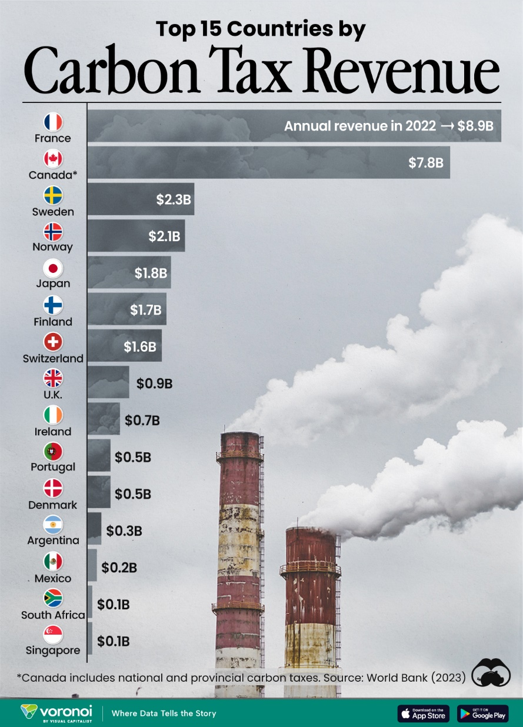

Figure Carbon Taxes from Countries (from www.visualcapitalist.com)